**KANBAN METHODOLOGY:**

**Kanban Methodology:**

Kanban methodology is an agile method that aims at continuous improvement, flexibility in [task management](https://kissflow.com/project/team/guide-to-task-management/), and enhanced workflow. With this illustrative approach, the progress of the whole project can be easily understood in a glance.

Kanban was used in manufacturing settings to control inventory throughout the supply chain, using a practice called just-in-time (JIT) manufacturing. In [project management](https://kissflow.com/project/project-management-basics/), the Kanban methodology adapts the same concept by ensuring that the amount of required work is the same as the work capabilities of the team.

**How does Kanban work:**

Kanban method revolves around the [kanban board](https://kissflow.com/project/agile/kanban-board-software/). It is a tool that visualizes the entire project to track the flow of their project. Through this graphical approach of Kanban boards, a new member or an external entity can understand what’s happening right now, tasks completed and future tasks.

**Kanban board indicates**

* the current tasks that are being performed
* the tasks to do in the future
* the tasks that are completed

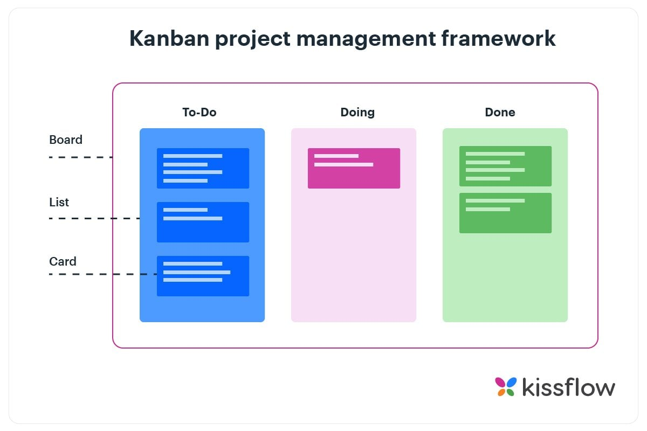

The divided columns are interconnected and tasks are gradually pulled from the leftmost column (future tasks) to the rightmost column (completed tasks). [Kanban system](https://kissflow.com/project/agile/effective-kanban-system/) measures the work cycle being completed through the principle of Work in Progress (WIP)*.* WIP has certain limits and a pre-defined specific status.

Limiting WIP in order to maintain consistent standards is one of the core principles that govern the Kanban methodology in Agile. It is extremely important for the team to complete the current tasks in the prescribed order.